**Program to simulate Point to Point topology [first.cc]**

//netAnimation

#include "ns3/netanim-module.h"

#include "ns3/mobility-module.h"

84.

AnimationInterface anim("first.xml");

AnimationInterface::SetConstantPosition (nodes.Get(0), 10, 25);

AnimationInterface ::SetConstantPosition(nodes.Get(1), 40,25);

anim.EnablePacketMetadata(true);

pointToPoint.EnablePcapAll("first");





In ns-3.32

* ./waf --run scratch/first
* ls

In netanim-3.108

* ./NetAnim

In NetAnim select your file and run

Export .**txt** file and create a .**plt** file:

set terminal png

set output "Lalit.png"

set title "Point to Point Toplogy end to end delay"

set xlabel "nodes"

set ylabel "end to end delay"

plot "data.txt" using 1: 5 with linespoint title "TimeDelay" lw 4,"data.txt" using 1: 6

with linespoint title "DBR " lw 2

run following command in ns-3.32 terminal

* gnuplot gplot.plt

**don’t know what it is**

* **./waf --run scratch/first.cc --vis**

**Program to simulate Bus topology [second.cc]**

//netAnimation

#include "ns3/netanim-module.h"

#include "ns3/mobility-module.h"

114.

//For Net Anim

MobilityHelper mobility;

mobility.SetMobilityModel("ns3::ConstantPositionMobilityModel");

mobility.Install(p2pNodes);

mobility.Install(csmaNodes);

AnimationInterface anim("second.xml");

AnimationInterface::SetConstantPosition (p2pNodes.Get(0), 10, 25);

AnimationInterface ::SetConstantPosition(p2pNodes.Get(1), 20,25);

AnimationInterface ::SetConstantPosition(csmaNodes.Get(1),40,25);

AnimationInterface ::SetConstantPosition(csmaNodes.Get(2),50,25);

AnimationInterface ::SetConstantPosition(csmaNodes.Get(3),60,25);

anim.EnablePacketMetadata(true);

**lan.plt**

set terminal pdf

set output "Anas.pdf"

set title "PtoP and Bus topology"

set xlabel "Nodes"

set ylabel "time delay"

plot "aaa.txt" using 1: 5 with linespoint title "LAN" lw 4

**Program to simulate Bus topology using UDP [udp-eco.cc]**

 

**Program to simulate Start topology [star.cc]**

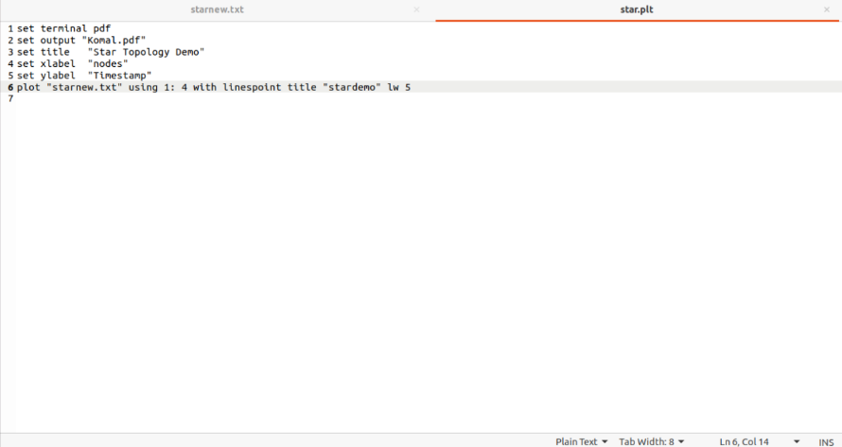

**Program to simulate Mesh topology**

**Program to simulate Hybrid topology [third.cc]**

//netanimation

#include "ns3/netanim-module.h"

169.

ApplicationContainer clientApps =

echoClient.Install (wifiStaNodes.Get (nWifi - 1));

clientApps.Start (Seconds (2.0));

clientApps.Stop (Seconds (10.0));

Ipv4GlobalRoutingHelper::PopulateRoutingTables ();

AnimationInterface anim("hybridWiFi.xml");

AnimationInterface::SetConstantPosition (p2pNodes.Get(0), 10, 25);

AnimationInterface ::SetConstantPosition(csmaNodes.Get(1), 40,25);

anim.EnablePacketMetadata(true);

pointToPoint.EnablePcapAll("hybridwifi");

**lan.plt**

set terminal pdf

set output "Belesh.pdf"

set title "Vikram Demo NS3 Lecture Graph"

set xlabel "Nodes"

set ylabel "Time To Live"

plot "Vikram.txt" using 1: 5 with linespoint title "TimeDelay" lw 4

**Program to simulate UDP Client Server**

//netAnimation

#include "ns3/netanim-module.h"

#include "ns3/mobility-module.h"

AnimationInterface anim("udp-cs.xml");

AnimationInterface::SetConstantPosition (n.Get(0), 10, 25);

AnimationInterface ::SetConstantPosition(n.Get(1), 40,25);

anim.EnablePacketMetadata(true);

csma.EnablePcapAll("udp-cs");